ADRIAN TURION |  | Avenue de Sainte-Clotilde 9  1205 Geneva, Switzerland | 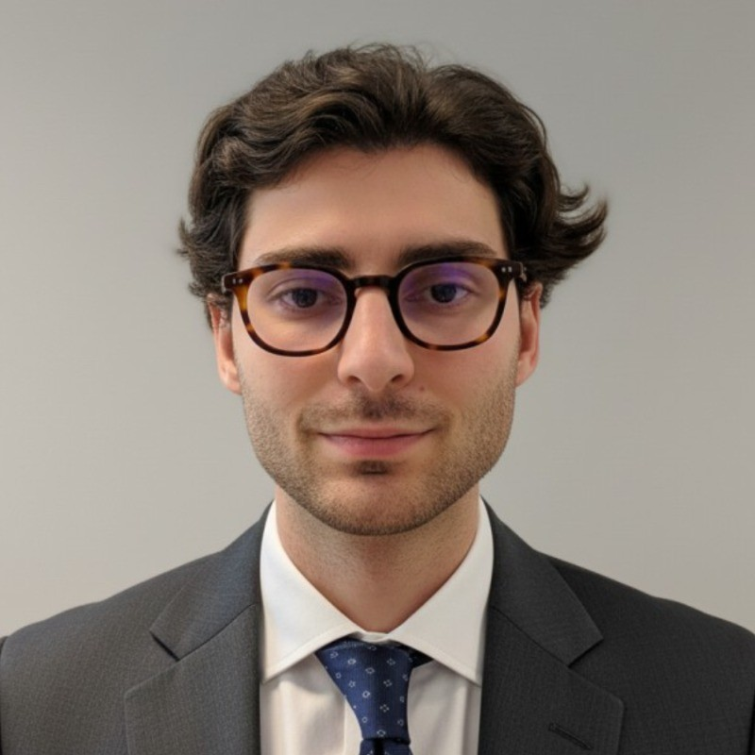
turionadrian@gmail.com | Swiss | 10.11.2000 |  | +41 77 262 37 96
INTRODUCTION
Analytically rigorous MSc Finance candidate with due diligence experience across 10+ transactions and strong Excel modeling skills. Entrepreneurial initiative demonstrated by founding an AI tool now used by 3 advisory firms. Systematic approach to data collection and performance analysis developed managing concurrent mandates in a lean deal team environment.
WORK EXPERIENCE
Auraïa Capital Advisory – Small & Mid Cap Cross-border M&A Boutique  Mergers & Acquisitions Analyst (Converted internship into full-time position) |  | Geneva, Switzerland  Aug 2024 – Current
- End-to-end execution exposure in a lean 3-person deal team, conducting due diligence, valuation analysis, and coordinating with legal and tax advisors to structure transactions worth EUR 5M to EUR 50M
- Built detailed financial models (LBO, DCF, trading comps) and prepared client presentations for Board meetings, developing expertise in systematic data collection and performance analysis across multiple sectors
- Led production of marketing materials and investor presentations, maintained buyer universes, and managed data rooms across concurrent mandates, ensuring precise documentation and timely delivery under tight deadlines

RC Group – Currently under LBO with Crédit Mutuel Equity  Mergers & Acquisitions Intern |  | Paris, France  Feb 2024 – Aug 2024
- Conducted financial and operational due diligence on acquisition targets (EUR 10M-30M revenue), prepared investment memos with market analysis and financial projections, and supported integration planning for the CEO of Healthcare and Retail divisions

Europ Assistance – Subsidiary of Generali Insurance  Financial Analyst Intern |  | Geneva, Switzerland  Apr 2023 – Aug 2023
- Built automated financial dashboards in Excel and PowerBI to track KPIs, performed variance analysis on monthly P&L results, and supported annual budget planning and quarterly forecasting for 5 business units at the CHF 50M+ revenue insurance subsidiary

LEADERSHIP
- Finalist in McKinsey-sponsored business case, presenting a data-driven predictive model for black swan market events to Keyrock management and McKinsey consultants
- Founded Screeny.ai, an AI-powered tool for investment banks to identify strategic acquirers, now used by 3 M&A advisory firms, reducing research time by 90%
- Manage a personal investment portfolio using systematic options strategies (Cash Secured Puts, Covered Calls), generating +8% annualized returns across positions
EDUCATION
HEC Lausanne  Master of Science in Finance |  | Lausanne, Switzerland  2021 – 2024
- Cumulative GPA: 5.2/6.0 (Top 15% of the class cohort)
- Exchange programs at Waseda University (Tokyo, Japan) and Maastricht University (Maastricht, Netherlands)
- Relevant Coursework: Data Science for Finance, Investments, Quantitative Asset and Risk Management, Derivatives
- Thesis Topic: Synergies Analysis of the Merger between American Airlines & US Airways

Bachelor of Science in Management |  | 2018 – 2021
- Cumulative GPA: 4.7/6.0

Scientific Baccalaureate with Highest Honors (16.6/20) |  | Aix-en-Provence, France
ADDITIONAL INFORMATION
Languages:  Computer:  Interests:  References: | French (Native, C2), Spanish (Native, C2), English (Fluent, C1), German (Business proficient, B2-C1)  Financial Modeling, Investment Analysis, Excel & VBA, PowerBI, Due Diligence  Geopolitics, Badminton (Provence regional finalist), Gym, Real use cases of Artificial Intelligence  Guillaume Arnaldez – Ex-Director at Auraïa Capital Advisory, guillaume.arnaldez@auraia.ch  Sacha Caravatti – CFO at Europ Assistance Switzerland, scaravatti@europ-assistance.ch

